ACCEPTANCE TEST procedure

FOR

15.6” MTID- RUGGED

BEL Part No: 4461 415 601 19

RAJMOHAN.K
PURUSHOTHAM REDDY
Prepared By
Checked By

Approved By

The Document is supplied on the express terms that it is to be treated as confidential and that it may not be copied, used or disclosed to others for any purpose except as authorized by Bharat Electronics, Ghaziabad.

Bharat Electronics
BHARAT NAGAR POST,
GHAZIABAD-201 010 (UP)

ISS | PAGE NO. | CP NO. | DATE | CHANGE | APPROVED BY
P1 |  |  | 21.03.2024 | ORIGINAL

This document describes the procedure for carrying out Acceptance on 15.6” MTID- RUGGED

CONTENTS

SL.NO. | DESCRIPTION | PAGE NO.
1 | Introduction
1.2 | Reference Documents
2 | Specifications
2.0.1 | Technical Specifications
2.0.2 | Input Power Supply Requirements
2.0.3 | Dimensions
2.0.4 | Mechanical Specifications
2.5 | Weight
3 | Software
4.0 | IO Connector details on 15.6” MTID-Rugged
5.0 | List of Deliverables
6.0 | Test Equipment Required
7.0 | Physical Inspection
7.1 | Visual
7.2 | Dimensions & Drawing Verification
8.0 | Functional Test Procedure
9.0 | Environmental Test Specifications
10 | EMI/EMC Specifications
11 | Environmental Test Procedure
11.1 | Vibration
11.2 | High Temperature (Operation)
11.3 | High Temperature (Storage)
11.4 | Damp Heat
11.5 | Low Temperature
11.6 | Drip Proof
11.7 | Tropical Exposure
11.8 | Mould Growth
11.9 | Corrosion Salt
11.10 | Shock Test
12 | EMI/EMC Test Procedures
12.1 | CE101 (Conducted Emissions, Power Leads, 30 Hz to 10 kHz)
12.2 | CE102 (Conducted Emissions, Power Leads, 10 kHz to 10 MHz)
12.3 | CS101 (Conducted Susceptibility, Power Leads, 30 Hz to 150 kHz)
12.4 | CS106 (Conducted Susceptibility, Power Leads, 200V,0.15μS±20%12)
12.5 | CS114 (Conducted Susceptibility, Bulk Cable Injection, 10 kHz to 200 MHz)
12.6 | CS115 (Conducted Susceptibility, Bulk Cable Injection, Impulse Excitation.)
12.7 | CS116 (CS, Damped Sinusoidal Transients, Cables and Power Leads, 10 kHz to 100 MHz)
12.8 | RE101 (Radiated Emissions, Magnetic Field, 30 Hz to 100 kHz)
12.9 | RE102 (Radiated Emissions, Electric Field, 10kHZ up to 18 GHz)
12.10 | RS101 (Radiated Susceptibility, Magnetic Field, 30 Hz to 100 kHz)
12.11 | RS103 (Radiated Susceptibility, Electric Field, 2 MHz to 40 GHz)
13 | Defect / Failure Analysis

TEST DATA RECORDS

SL.NO. | DESCRIPTION | PAGE NO.
1 | Test Data Record-1: Physical Inspection
2 | Test Data Record-2: Vibration
3 | Test Data Record-3: High Temperature
4 | Test Data Record-4: Damp Heat
5 | Test Data Record-5: Low Temperature
6 | Test Data Record-6: Drip Proof
7 | Test Data Record-7: Tropical Exposure
8 | Test Data Record-8: Mould Growth
9 | Test Data Record-9: Corrosion Salt
10 | Test Data Record-10: Shock Test
11 | Test Data Record-11

LIST OF IMAGES

IMAGE NO. | IMAGE NAME | PAGE NO.
IMAGE-1 | Unit Image
IMAGE-2 | Test Setup
IMAGE-3 | Shock Test
IMAGE-4 | CE101 limit for Navy ASW aircraft and Army aircraft applications.
IMAGE-5 | CE101 Test Setup
IMAGE-6 | CE101 Calibration Image
IMAGE-7 | CE101 Measurement image
IMAGE-8 | CE102 limit (EUT power leads, AC and DC) for all applications.
IMAGE-9 | CE102 Test setup image
IMAGE-10 | CE102 Calibration Image
IMAGE-11 | CE102 Measurement Test setup Image
IMAGE-12 | CE102 Receiver
IMAGE-13 | CS101 limit line Image
IMAGE-14 | CS101 Calibration image
IMAGE-15 | CS101 Test Setup Image
IMAGE-16 | Signal Injection, DC or Single-phase AC
IMAGE-17 | CS106 limit line image
IMAGE-18 | CS106 Test Setup
IMAGE-19 | Calibration image
IMAGE-20 | Signal injection, DC or single-phase AC
IMAGE-21 | CS114 Limit for Ground Equipment
IMAGE-22 | CS114 Bulk Cable Injection Block Diagram
IMAGE-23 | CS115 Signal Characteristics
IMAGE-24 | Typical Setup for CS115 Bulk Cable Injection
IMAGE-25 | Typical CS116 Damped Sinusoidal Waveform.
IMAGE-26 | CS116 Current Limit
IMAGE-27 | CS116 Test Setup
IMAGE-28 | Typical Setup for Bulk Cable Injection of Damped Sinusoidal Transients
IMAGE-29 | RE101 limit for all Navy applications
IMAGE-30 | Calibration Configuration image
IMAGE-31 | Test Setup for RE101
IMAGE-32 | RE102 Limit for Ground Applications
IMAGE-33 | RE102 General Test Setup
IMAGE-34 | RE102 Basic Test Setup
IMAGE-35 | Antenna Position
IMAGE-36 | RS101 limit for all Navy applications
IMAGE-37 | RS101 Test Setup Image
IMAGE-38 | Configuration Test Setup image
IMAGE-39 | Calibration of the radiating system
IMAGE-40 | RS103 Basic Test Equipment Configuration (Using Sensor)
IMAGE-41 | RS103 Basic Test Equipment Configuration (Using Receive Antenna)

LIST OF TABLES

TABLE NO. | TABLE DESCRIPTION | PAGE NO.
Table-1 | ENVIRONMENTAL TEST SPECIFICATIONS
Table-2 | EMI/EMC SPECIFICATIONS
Table-3 | Vibration Test Specifications
Table-4 | High Temperature (Operational)
Table-5 | High Temperature (Storage)
Table-6 | Damp Heat
Table-7 | Low Temperature
Table-8 | Shock Test
Table-9 | Shock test specification
Table-10 | CE101 Bandwidth and measurement time
Table-11 | CE101 Bandwidth and measurement time
Table-12 | RE101 Bandwidth and measurement time
Table-13 | RS101 Susceptibility Scanning

LIST OF ABBRIVATIONS

- ATP --- Acceptance Test Report

- LCD --- Liquid Crystal Display

- LED --- Light Emitting Diode

- MDI --- Master Drawing Index

- BOM --- Bill of Material

- EMI --- Electromagnetic interference

- EMC --- Electromagnetic Compatibility

- EUT --- Equipment

- OSD --- On Screen Display

- AC --- Alternating Current

- DC --- Direct Current

- HDMI --- High-Definition Multimedia Interface

- DVI --- Digital Visual Interface

- USB --- Universal Serial BUS

- mDP --- Mini Display Port

- PC --- Personal Computer

- TDR --- Test Data Record

- INTRODUCTION:
This document specifies the functions, construction and performance of the “15.6” MTID-RUGGED”. It lays down the outline specifications on the functional, electrical, mechanical and environmental characteristics of the equipment.

This item is being supplied by M/s Datasol Pvt Limited, Bangalore.

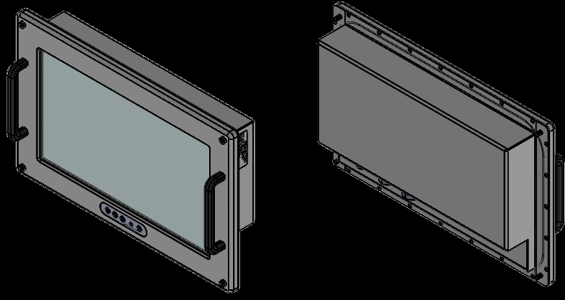

Image-1: Unit

Brief Description:
“15.6” MTID-RUGGED” is a 15.6” display with up to 1920x1080 resolution and sunlight readable LCD, with high brightness 1200 nits and high color saturation, it produces sharp images, crisp text and life like colors. The Durapixel LED backlight technology ensure high reliability and low power consumption.
1.2 REFERENCE DOCUMENTS
1.2.1 Environmental Test as per JSS 55555:2012
1.2.2 EMI/EMC Test as per MIL Std.461E & F.
1.2.3 MDI/BOM Part no: PP drawing includes BOM (PP No: 4461 415 601 19)
1.2.4 BEL PO No.. BEPO / GD3 / 4000392872 dated 29.05.2023
1.2.5 Approved Specifications are as per BEL PP drawing (PP No: 4461 415 601 19)

2.0 SPECIFICATIONS
2.0.1 Technical Specifications:
- Display Size : 15.6"
- Resolution : 1920 x 1080 @ 60Hz
- Aspect Ratio : 16:9
- Brightness : 1200 cd/m2
- Contrast Ratio : 1200:1
- Wide Viewing Angle : 170° H / 170° V (min)
- Display Colour : 16.2M
- Anti-Reflective, Toughened EMI protective glass with 90% visibility
- LED Backlighting and brightness control to be provided.
- TOUCH SCREEN: PCAP-MULTI-TOUCH WITH GLASS PROTECTION
- On Screen Display (OSD): Water Sealed Membrane OSD Keypad
- Display with Optical bonding
- Operating System Support: Support and touch driver for RHEL 8.1 and higher Edition

2.0.2. Input Power Supply Requirements:
AC 230V±10%, 50-60Hz ± 3Hz

2.0.3. Dimensions:
The following are the dimensions of 15.6” MITD-Rugged: WXHXD- 436x281x74.5.

2.0.4. Mechanical Specifications:
- Paint & Finish: Paint RFU Fire Retardant, colour Black (PS 613-BK-SGL), finish semi-gloss.
- Sealing: IP 65 from all sides
- Material type: Al Alloy (64430/53000 NS5) or Stainless Steel AISI 316L Grade
- Fasteners: SSI grade AISI 316L
- Mounting: Panel mount
- Enclosure: Rugged Corrosion Resistant enclosure.

2.5. Weight: 7 Kgs (approx.)

3.0 SOFTWARE:
Module is not software driven, hence documentation is not applicable

4.0. IO Connector details on 15.6” MTID-Rugged:
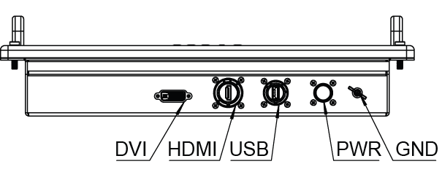
- Power Input : D38999/20WB5PN ------ 01 No
- HDMI Input : HDMI FTV 2A ------------ 01 No
- DVI Input : Standard Connector ---- 01 No
- USB Input : USBFTV 21G ------------- 01 No

5.0: List of Deliverables:
- 15.6” MTID-Rugged Unit : 26 Nos.
- 1.8 Meters circular Power cable : 28 Nos.
- 2.5M Length DVI Male to mDP cable : 28 Nos.
- 2.5M Length HDMI to mDP cable : 28 Nos.
- 2.5M length USB M-M cable : 28 Nos.
6.0 TEST EQUIPMENT REQUIRED:
- 15.6” MTID-Rugged Unit : 1 No.
- Standard PC with mDP/HDMI/DVI Port : 1 No.
- Power cables for Standard PC : 1 Nos.
- Power cable for 15.6” MTID-Rugged : 1 Nos.
- USB Male to Male cable for Touch Interface : 1 Nos.
- DVI Male to mDP Male cable : 1 Nos.
- HDMI to mDP Male cable : 1 Nos.

7.0 PHYSICAL INSPECTION:
7.1 Visual:
1.Check the Display for any damages
2. Check if the power circular connector is properly mating at the Dispaly end and also clearly inserted at the power socket.
3. Check all the connectors power & signal for any loose pins/wires.
4. Note down the result in TDR-1.

7.2 Dimensions & Drawing Verification:
1. Physical inspection of the unit is to be carried out wrt dimensions, mounting and other details as per drawing and note down the measured dimensions in TDR-1.

8.0 Functional Test Procedure:
1. Connect the Display HDMI port to standard PC mDP port by using mDP to HDMI cable. And also Connect USB male to male cable from PC USB port to Display rear side USB port.
After switching ON the standard PC and display, check the system booting and display seen on the screen of Display. Check the resolution support 1920x1080 and check the touch by touching on display icon/text.

2.Now remove the mDP to HDMI cable and Connect Display DVI port to standard PC mDP port by using mDP to DVI cable.
After switching ON the standard PC and display, check the system booting and display seen on the screen of Display. Check the resolution support 1920x1080 and check the touch by touching on display icon/text.
3. Note down the results in TDR-11.
4. After checking, shutdown the system and switch off the Display Unit.

8.1 TEST SETUP:
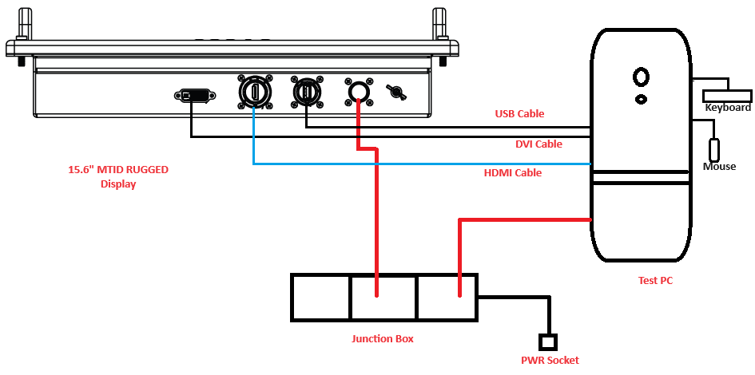

Image-2: Test Setup

9.0 ENVIRONMENTAL Test Specifications:
Reference Std: JSS 55555:2012
Sl.  No | Test Name | TEST No. | Specification | Remarks
 | Vibration | 28 | 5 to 33 Hz, ±0.125 mm constant displacement | The Equipment should be in switched ‘ON’ condition during the test.  The equipment would be mounted on the vibration table by its normal means of attachment on ship
2 | High Temperature  (operational) | 17 | Procedure: 6  Test Condition K (For Protected & Submersible)  Temp: 55°C  Duration: 16 Hrs, | Performance Check last hour
3 | High Temperature  (Storage) | 17 | Procedure: 6  Test Condition K (For Protected & Submersible)  Temp: 70°C  Duration: 16 Hrs, | Performance Check last hour
4 | Damp Heat | 10 | Operating Temp: 40°C  RH: 95%  Duration: Unpacked and switched OFF: 15 h 30 Mins  Unpacked and switched ON: 30 Mins  Total: 16 Hrs duration
5 | Low Temperature | 20 | Temp : -10° C  Duration: 16 hours  Test Condition: H  Procedure:4 | Power will be available  in last ½ hour of the  test. Unit should switch  ON immediately after  powering ON.  Performance Check  during last 30 mins.
6 | Drip Proof | 11 | Duration: 15 Min | Equipment should be operated during the test.
7 | Tropical Exposure | 27 | Test Condition A:7 cycles  Temp: 20 °C to 35 °C  RH: 95%  Duration: 24 hrs (one cycle)
8 | Mould Growth | 21 | Temp: 30°C  RH :> 90%  Duration: 28 days | To be conducted on representative samples
9 | Corrosion Salt | 9 | Procedure 2  Temp: 35°C  RH: 90 to 95% | To be conducted on representative samples
10 | Shock Test | - | The equipment should be able to withstand following shock severities: - Pulse shape: Half sine wave Peak  acceleration: 20 g, 11 msec, all 3 axes. | Equipment should be  in switched ‘OFF’  condition.  Visual and functional  checks after the test.
Table-1: ENVIRONMENTAL TEST SPECIFICATIONS

10. EMI/EMC SPECIFICATIONS
The Equipment should meet the MIL STD 461 E & F applicable for Equipment below the Deck in Naval applications. Based on standard for Surface ships the applicable tests are as per below Table-2

Sl.No | PARAMETER | Test | TEST DESCRIPTION
1 | MIL STD-461E/F | CE101 | Conducted Emissions, Power Leads, 30 Hz to 10 kHz
2 | MIL STD-461E/F | CE102 | Conducted Emissions, Power Leads. 10 KHZ to 10 MHZ
3 | MIL STD-461E/F | CS101 | Conducted Susceptibility, Power Leads, 30 Hz to 150 KHz
4 | MIL STD-461E/F | CS106 | Conducted Susceptibility, Power Leads, 200V,0.15μS±20%
5 | MIL STD-461E/F | CS114 | Conducted susceptibility, bulk cable injection. 10 KHZ to 200 MHZ
6 | MIL STD-461E/F | CS115 | Conducted susceptibility, bulk cable injection. Impulse Excitation
7 | MIL STD-461E/F | CS116 | Conducted susceptibility, damped sinusoidal transients.Cables and power leads.10 KHZ to 100 MHZ
8 | MIL STD-461E/F | RE101 | Radiated Emissions, Magnetic Field, 30 Hz to 100 kHz
9 | MIL STD-461E/F | RE102 | Radiated Emissions, 10 kHz up to 18 GHz
10 | MIL STD-461E/F | RS101 | Radiated Susceptibility, Electric Field, 30 Hz to 100 kHz.
11 | MIL STD-461E/F | RS103 | Radiated Susceptibility, Electric Field, 2 MHz to 40 GHz.

11. Environmental Test Procedure:

11.1 Vibration

Object
To determine the suitability of electronic and electrical equipment to withstand specified severities of vibration.

Purpose
This test is performed to determine if test items can be operated under severe physical dynamic condition without experiencing physical damage or deterioration in performance.

Test Objectives
The primary objective of the test is to determine whether: -
      - The basic design is adequate to withstand the specification requirement.
      - Design modifications are necessary to make it withstand the test severities.
      - Incorporation of isolation mechanism required in the event of inadequacies due to constraints in the design to make it functional under the severe dynamic conditions.
Test Specification: |  | Remarks
Vibration.  Test No. 28 | 5 to 33 Hz, ±0.125 mm constant displacement | The Equipment should be in switched ‘ON’ condition during the test.  The equipment would be mounted on the vibration table by its normal means of attachment on ship
Table-3: Vibration Test Specifications
Test Procedure
Step 1-Mount the test item with its fixture on the vibration table.
Step 2-Expose the test item in ‘unpacked’ and ‘switched-on’ condition to the Vibration test level and duration as specified.
Step 3-Repeat steps 2 & 3 for each axis.
Final Measurement
The equipment shall be visually examined and electrically and mechanically checked as specified and record the results in TDR-2

11.2 High Temperature (Operation)
Purpose
High temperature operation test is performed to determine if test items can be operated under hot environmental conditions without experiencing physical damage or deterioration in performance.

Test Objectives
The primary objectives of the High Temperature operation test are to determine if: -
    - The test item will operate without degradation after storage in a climatic which induces high temperature within the test item.
    - The test item can be operated and handled without affecting its integrity in a high temperature climate.
    - The test item is safe during and following high temperature exposure
Specifications
Temperature | +55° C
Duration | 16 hours
Procedure | 6
Condition | K
Performance Check | Last Hour

Table-4: High Temperature (Operational)
Test Procedure
Step 1 - With the test item placed in the chamber in its ‘unpacked’ and ‘switched-off’ condition, adjust the chamber air conditions to the specified operational test temperature level of 55⁰C.
Step 2 - Expose the test item to this temperature level till the stability is attained and then maintain for applicable hours.
Step 3 - Performance test the item and carryout operational check outs at 55⁰C during last 1 hour of the conditioning period and record the results in the test report.
Step 4 - Switch off the test item and adjust the chamber air temperature to standard laboratory ambient and maintain until temperature stabilization of the test item has been achieved.
Step 5 - Conduct an operational checkout at ambient temperature.
Final Measurement
The equipment shall be visually examined and electrically and mechanically checked as specified and record the results in TDR-3

11.3 High Temperature (Storage)
Purpose
High temperature storage test is performed to determine if test items can be operated under hot environmental conditions without experiencing physical damage or deterioration in performance.

Test Objectives
The primary objectives of the High Temperature storage test are to determine if: -
    - The test item will operate without degradation after storage in a climatic which induces high temperature within the test item.
    - The test item can be operated and handled without affecting its integrity in a high temperature climate.
    - The test item is safe during and following high temperature exposure
Specifications
Temperature | +70° C
Duration | 16 hours
Procedure | 6
Condition | K
Performance Check | Last Hour

Table-5: High Temperature (Storage)
Test Procedure
Step 1 -With the test item placed in the chamber in its ‘unpacked’ and ‘switched-off’ condition, adjust the chamber air conditions to the specified storage of 70⁰C for applicable hours.
Step 2 - Expose the test item to this temperature level till the stability is attained and then maintain for applicable hours.
Step 3 - Performance test the item and carryout operational check outs at 70⁰C during last 1 hour of the conditioning period and record the results in the test report.
Step 4 - Switch off the test item and adjust the chamber air temperature to standard laboratory ambient and maintain until temperature stabilization of the test item has been achieved.
Final Measurement
The equipment shall be visually examined and electrically and mechanically checked as specified and record the results in TDR-3

11.4. Damp Heat
Specifications
Temperature | +40°C
Duration | 16 hours
RH Value | 95 %
Performance Check | Last 30 Min

Table-6: Damp Heat
Objective

To determine the suitability of electronic and electrical equipment for use under conditions of high humidity.

Test Procedure
The equipment shall be visually examined and shall be electrically and mechanically checked as specified.

Conditioning
Step1: The equipment under test shall be subjected to the test in its' unpacked' and 'switched-off' condition.
Step2: The equipment under test, while being under the laboratory atmospheric conditions shall be introduced into the chamber, the latter also being under the same conditions. The temperature and relative humidity of the chamber shall then be raised to 40ºC and not less than 95 percent respectively.
Step3: The equipment shall be conditioned under these conditions for a period of 16 hours.
Step4: During the last 30 minutes of the period, the equipment shall be switched ON and a performance check, as specified, shall be carried out.
Step5: The temperature of the chamber shall then be restored to the laboratory atmospheric conditions in not less than an hour. Saturation of the chamber atmosphere with water vapor shall occur during this period. The equipment shall then be exposed to these conditions for a period of not less than 3 hours.
Recovery
The equipment shall be recovered from the chamber and shall be allowed to remain under standard recovery conditions for a period of 2 to 4 hours.
Final Measurements The equipment shall be visually examined and shall be electrically and mechanically checked as specified and record the results in TDR-4
11.5 Low Temperature
Purpose
Low temperature chamber tests are performed to determine if material can be stored, manipulated, and operated under pertinent low temperature conditions without experiencing physical damage or deterioration in performance.
Test Objectives
The primary objectives of the low temperature test are to determine if:
1.The test item can meet the performance specifications during operation in a cold environment.
2. The test item can be operated safely during or following low temperature exposure.
Test Specification
Specifications
Temperature | -10°C
Duration | 16 hours
Procedure | 4
Condition | H
Performance Check | Last 30 Min

Table-7: Low temperature
Test Procedure
Step1: With the test item placed in the chamber in its ‘unpacked’ and ‘Switched-OFF’ condition, adjust the chamber air conditions to the specified operational test temperature of -10⁰C. Maintain until temperature stabilization of the test item has been achieved and soak the equipment for applicable hours.
Step 2: Conduct an operational checkout of the test item after soaking period during last 30 Min.
Step 3: Switch off the test item and adjust the chamber air temperature to standard laboratory ambient and maintain until temperature stabilization of the test item has been achieved.
Step 4: Conduct a complete visual examination of test item.
Final Measurement
The equipment shall be visually examined and electrically and mechanically checked as specified and record the results in TDR-5

11.6 DRIP PROOF
Object
To determine the suitability of unsealed electronic and electrical equipment in service to water droplets falling on it

TEST EQUIPMENT
Step1: The water used for the test shall be clean tap water. The water from the nozzle shall fall vertically downwards on to the surface of the equipment from a height of one meter. The water level in dispenser shall be maintained constant by adjusting the water flow to the dispenser.

Step2: Distance between two dispensers shall be 25mm and distance between water level and dispenser level shall be 76 ±1.6 mm. Total level of water shall be 300 mm

TEST PROCEDURE
Step1: The equipment shall be subjected to this test in its un packed condition
Step2: The equipment under test, while being under the laboratory atmospheric conditions shall be positioned below the drip dispenser in its normal operational attitude.
Step3: Unless otherwise specified, any removable covers of the equipment shall be fixed in position as in normal operations. Sockets, terminal boxes, pipe and other entries shall be protected either by fitting the normal connectors and pipes or equivalent sealing blocks.
Step4: The equipment shall be subjected to this test for a period of 15 minutes.
Step5: The equipment shall be operated during this test.
Step6: At the conclusion of the test, the equipment shall be visually examined for ingress of water.
Recovery
Unless otherwise specified, all the external surfaces of the equipment shall be dried by wiping or by applying a clean blast of air at room temperature.
Final Measurements
The equipment shall then be visually examined and electrically and mechanically checked as specified and record the results in TDR-6

11.7 Tropical Exposure
Objective
To determine the suitability of electronic and electrical equipment for use and storage under conditions of high humidity when combined with cyclic temperature changes.

Test Procedure
Step1: The equipment under test, shall be subjected to this test, in the `unpacked' and switched-off' condition
Step2: The equipment under test while being under the laboratory atmospheric conditions shall be introduced into the chamber maintained at a temperature of 20°C ±5°C
Step3: The temperature and relative humidity of the chamber shall then be raised to 35°C ±2°C and 95% respectively over a period of 3 hours
Step4: The above conditions shall be maintained for a period of 12 hours.
Step5: The temperature of the chamber shall then be lowered to 20°C ± 5°C over a period of 3 hours. Saturation of the chamber atmosphere with water vapour shall occur during this period.
Note: Condensation may occur during the cooling period but water shall not drip onto the equipment from the roof of the chamber.
Step6: The temperature of the chamber shall then be maintained at 20°C ± 5°C for a period of 6 hours
Step7: If required, the equipment shall be switched ON and operated during the first two hours of the 35°C period of each seventh cycle

Recovery
The equipment shall be removed from the chamber and shall be allowed to remain under standard recovery conditions for a period of 2 to 4 hours.

Final Measurements
The equipment shall be visually examined and shall be electrically and mechanically checked as specified and record the results in TDR-7

11.8: Mould Growth:
Note: To be conducted on representative samples
OBJECT:
To determine the resistance of electronic and electrical equipment against mould growth.
Test Procedure:
Initial Measurement:
The equipment shall be visually examined and shall be electrically and mechanically checked as specified.
Step1: The equipment and three control strips shall be sprayed with the mixed spore suspension prepared as in the mould suspension shall be prepared in distilled water to which has been added 0.05 percent of a non- fungicidal wetting agent. An agent based on N-methyl taurid, (Igepon) or on Dicotyl Sodium Sulphosuccinate is suitable.
The spray shall be generated by a nozzle large enough not to be blocked by the fragments of mycellum. The spray shall impinge on all exposed surfaces of the equipment.
Step2: Within 15 minutes of spraying the equipment and the control strips shall be introduced into the chamber whose working space is maintained at a temperature of 30ºC ± 1 deg C and a relative humidity of not less than 90 percent.
Step3: The equipment and the control strips shall not be unduly disturbed except for opening the chamber door each week until completion of the test.
Step4: If no mould growth is visible on any one of the control strips when the chamber door is opened for the first time after 7 days of starting the test, the test shall be considered void and shall be recommenced.
Step5: Provided that the mould growth on the control strips indicates that the conditions are suitable and the moulds viable, the equipment shall be exposed in the chamber continuously for a total period of 28 days.
Step6: The equipment shall be removed from the chamber after the 28 days of exposure and examined immediately under 10 power magnification.
Note: This microscopic examination shall be completed within a very short period as the mould growth begins to dry and changes in appearance rapidly when exposed to the laboratory conditions.
Step7: Unless otherwise specified, there shall be no mould growth when examined as clause in Step6
Recovery:
The equipment shall then be allowed to remain under standard recovery conditions for 2 to 4 hours.
Final Measurements
The equipment shall be visually examined and shall be electrically and mechanically checked as specified and record the results in TDR-8.

11.9: Corrosion Salt
Object:
To determine the suitability of electronic and electrical equipment for use and/or storage in salt laden atmosphere. This test is intended mainly for evaluating the quality and uniformity of protective coatings

Test Procedure:
Initial Measurement:
The equipment shall be visually examined and shall be electrically and mechanically checked as specified. In case dummy equipment is used for the test, only visual examination shall be done

Step1: The equipment under test, while being under laboratory atmospheric conditions shall be introduced into the salt spray chamber, the latter also being under the same conditions.
Step2: The equipment shall then be exposed to the salt mist, with the spray operating, for a period of 2 hours under the laboratory atmospheric conditions
Step3: The quantity of solution sprayed per hour shall be approximately one percent of the volume of the chamber
Step4: The equipment shall then be stored at a temperature of 35ºC ± 2ºC and a relative humidity of 90 to 95 percent for a period of 22 hours
Step5: The procedure specified in clauses Step2 to Step4 constitutes one cycle. The equipment shall be subjected to a total of three consecutive cycles as above
Step6: The equipment shall then be removed from the chamber and shall be examined for corrosion and deterioration of metal parts, finishes, materials and components

Recovery
- If required, the equipment may be washed in running tap water for 5minutes, rinsed in distilled water or demineralized water, then shaken by hand or subjected to air blast to remove droplets of water and dried for 1 hour at 55ºC ± 2ºC. The equipment shall then be allowed to remain under standard recovery conditions for a period of 2 to 4 hours

Final Measurements –
The equipment shall be visually examined and shall be electrically and mechanically checked as specified and record the result in TDR-9. In case dummy equipment is used for the test, only visual examination shall be done Final Measurements.
Note: There are no samples to be conduct this test, hence this test is omitted.

11.10: Shock Test
Object:
To determine the structural integrity and performance of electronic and electricalequipment when they are subjected to non-repetitive mechanical shocks
Initial Measurement:
The equipment shall be visually examined and shall be electrically and mechanically checked as specified.
Test Specification:
Specification | 20g, Pulse shape: half sine wave peak
Duration | 11m sec
Condition | Equipment should be in switched ‘OFF’ condition
Axis | All 3 Axis
Table-8: Shock Test
Test Procedure:
Step1: The impact machine shall be fitted with a target plate to which the equipment under test is secured.
The shock machine shall be capable of generating a pulse approximating to below of the nominal accelerations versus time curves:
Step2: The true value of the actual pulse shall be within the limit of tolerance as shown by the solid lines in the relevant Fig.
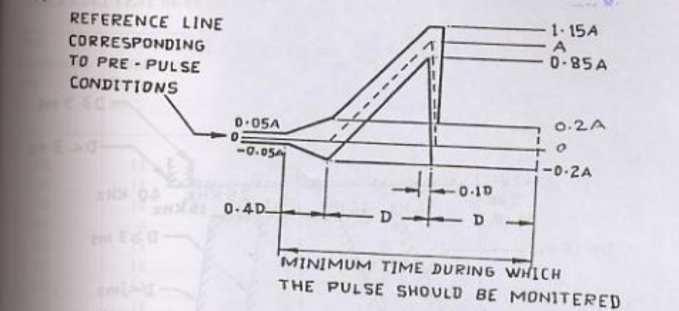
Image-3: Shock Test
---------Normal Pulse
______Tolerances Boundaries
D = Duration of Nominal Pulse
A = Peak Acceleration of Nominal Pulse

The reference line shall not differ more than ±0.05 a or ±10 m/s2, whichever is greater from zero acceleration.
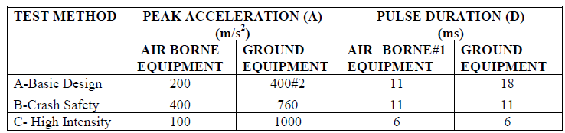
Table-9: Shock Test Specification
#1 Recommended for equipment shock mounted or weighing 140 kg or more.
#2 For equipment installed only in trucks or semi-trailers peak acceleration of 200 m/s2 may be specified.
Final Measurements
The equipment shall be visually examined and shall be electrically and mechanically checked as specified and record the results in TDR-10

12. EMI/EMC Test Procedures
12.1: CE101 (Conducted Emissions, Power Leads, 30 Hz to 10 kHz)
CE101 applicability:
This requirement is applicable for power leads, including returns, that obtain power from other sources not part of the EUT.

CE101 Purpose
This test procedure is used to verify that electromagnetic emissions from the EUT do not exceed the specified requirements for power input leads including returns

CE102 Limit:
Conducted emissions on power leads shall not exceed the applicable values shown on below figure.
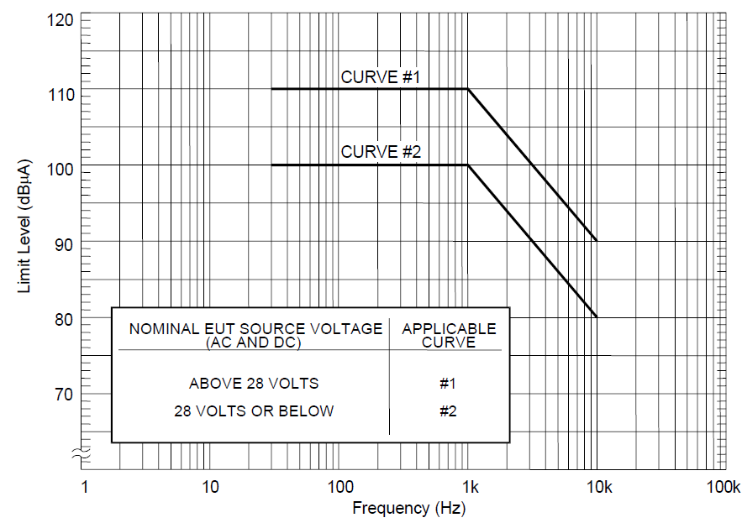
Image-4: CE101 limit for Navy ASW aircraft and Army aircraft (including flight line) applications.

CE101 Test setup
Step1- Maintain a basic test setup for the EUT as shown and described in below Figures. The LISN may be removed or replaced with an alternative stabilization device when approved by the procuring activity
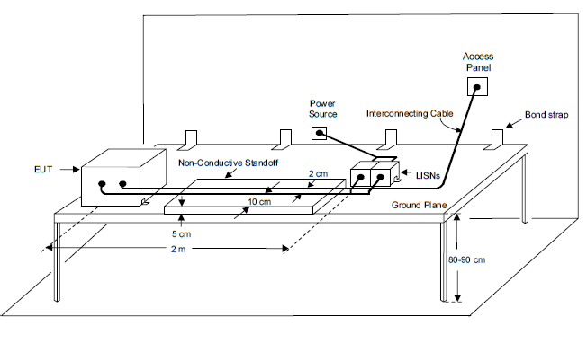
Image-5: CE101 Test Setup
CE101 Calibration.
Configure the test setup for the measurement system check as shown in below figure
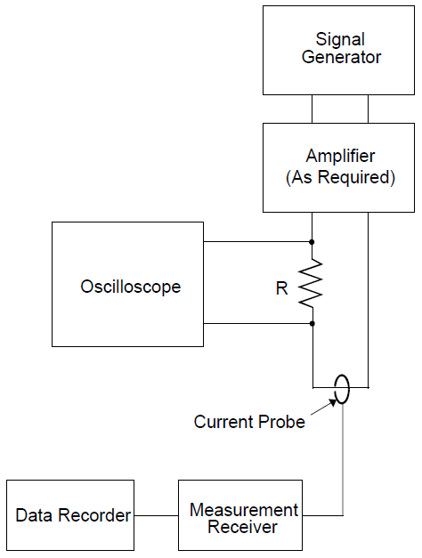
Image-6: CE101 Calibration Image

CE101 Measurement Test setup
Configure the test setup for compliance testing of the EUT as shown in below image

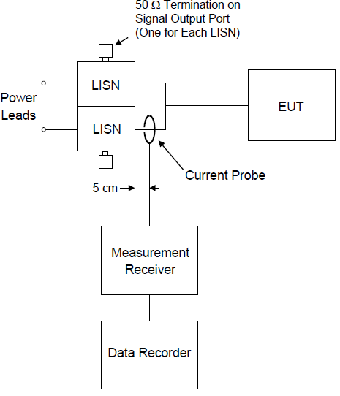
Image-7:CE101 Measurment image
CE101 Test Procedures
The test procedures shall be as follows:
Step1- Turn on the measurement equipment and allow a sufficient time for stabilization.
Step2- Calibration. Evaluate the overall measurement system from the current probe to the
data output device.
Step2.1- Apply a calibrated signal level, which is at least 6 dB below the applicable limit at 1 kHz, 3 kHz, and 10 kHz, to the current probe.
Step2.2- Verify the current level, using the oscilloscope and load resistor; also, verify that the current waveform is sinusoidal.
Step2.3- Scan the measurement receiver for each frequency in the same manner as a normal data scan. Verify that the data recording device indicates a level within ±3 dB of the injected level.
Step2.4- If readings are obtained which deviate by more than ±3 dB, locate the source of the error and correct the deficiency prior to proceeding with the testing.
Step3- EUT testing. Determine the conducted emissions from the EUT input power leads, including returns.
Step3.1- Turn on the EUT and allow sufficient time for stabilization.
Step3.2- Select an appropriate lead for testing and clamp the current probe into position.
Step3.3- Scan the measurement receiver over the applicable frequency range, using the
bandwidths and minimum measurement times specified in below Table-10.
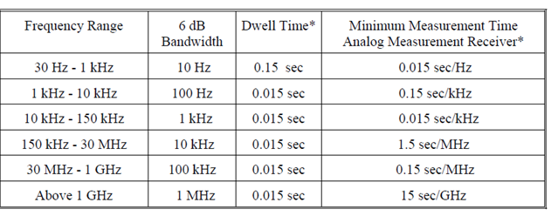
Table-10: CE101 Bandwidth and measurement time
Step3.4- Repeat Step3 for each power lead.
Final Measurements
The equipment shall be visually examined electrically and mechanically checked as specified and record the results in TDR-11

12.2. CE102 (Conducted Emissions, Power Leads, 10 kHz to 10 MHz)
CE102 Applicability:
This requirement is applicable from 10 kHz to 10 MHz for all power leads, including returns that obtain power from other sources not part of the EUT.

CE102 Purpose
This test procedure is used to verify that electromagnetic emissions from the EUT do not exceed the specified requirements for power input leads, including returns.

CE102 Limit:
Conducted emissions on power leads shall not exceed the applicable values shown on below Figure
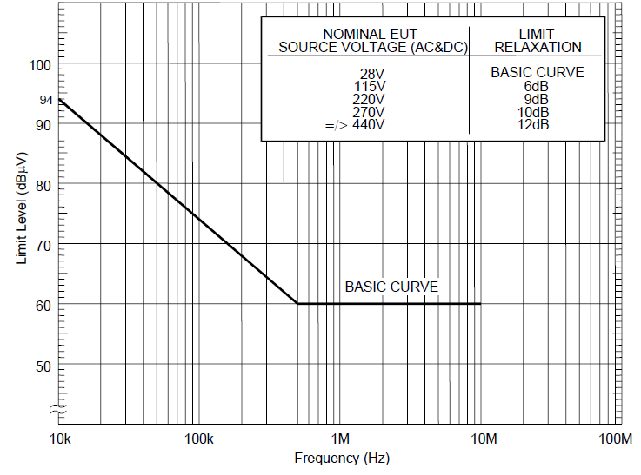
Image-8: CE102 limit (EUT power leads, AC and DC) for all applications.

CE102 Test Setup
Maintain a basic test setup for the EUT as shown and described in below Figures
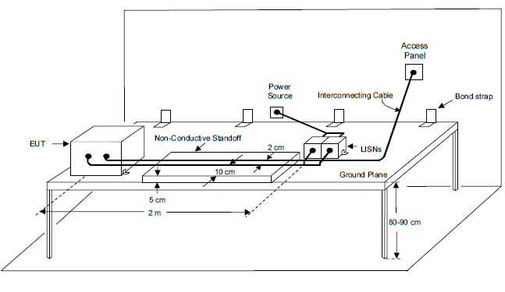
Image-9: CE102 Test setup image
CE102 Calibration:
Configure the test setup for the measurement system check as shown in below Figure. Ensure that the EUT power source is turned off.
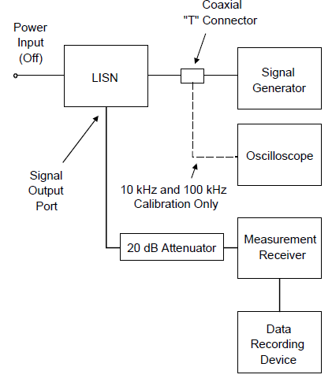
Image-10: CE102 Calibration Image
CE102 Measurement Test setup:
Connect the measurement receiver to the 20 dB attenuator on the signal output port of the LISN.
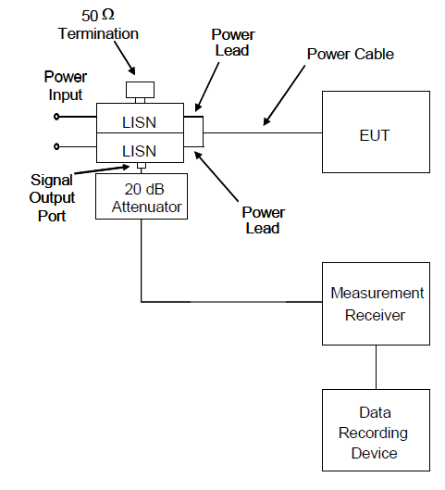
Image-11: CE102 Measurement Test setup Image

CE102 Test Procedure:
The test procedures shall be as follows:
Step1- Calibration. Perform the measurement system check using the measurement system check setup of Figure-10
Step1.1- Turn on the measurement equipment and allow a sufficient time for stabilization.
Step1.2- Apply a signal level that is at least 6 dB below the limit at 10 kHz, 100 kHz, 2MHz and 10 MHz to the power output terminal of the LISN. At 10 kHz and 100 kHz, use an oscilloscope to calibrate the signal level and verify that it is sinusoidal. At 2 MHz and 10Hz, use a calibrated output level directly from a 50 Ω signal generator
Step1.3- Scan the measurement receiver for each frequency in the same manner as a
normal data scan. Verify that the measurement receiver indicates a level within ±3 dB of the injected level. Correction factors shall be applied for the 20 dB attenuator and the voltage drop due to the LISN 0.25 μF coupling capacitor (see Image-12).

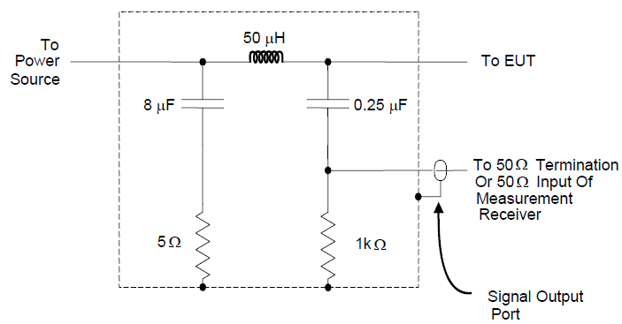
Image-12: CE102 Receiver
Step1.4- If readings are obtained which deviate by more than ±3 dB, locate the source of
the error and correct the deficiency prior to proceeding with the testing.
Step1.5- Repeat Step1.2 through Step1.4 for each LISN.
Step2- EUT testing. Perform emission data scans using the measurement setup of Figure-11
Step2.1- Turn on the EUT and allow a sufficient time for stabilization.
Step2.2- Select an appropriate lead for testing.
Step2.3- Scan the measurement receiver over the applicable frequency range, using the
bandwidths and minimum measurement times in the below Table.
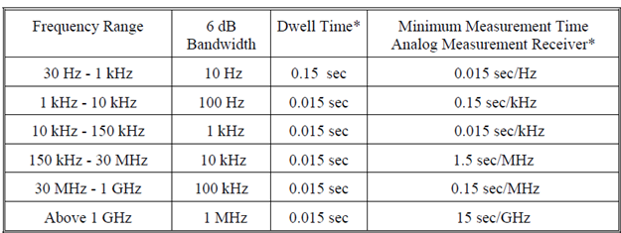
Table-11: CE101 Bandwidth and measurement time
Step2.4- Repeat Step2.2 and Step2.3 for each power lead.
Final Measurements
The equipment shall be visually examined electrically and mechanically checked as specified and record the results in TDR-11
12.3. CS101 (Conducted Susceptibility, Power Leads, 30 Hz to 150 kHz)
CS101 applicability
This requirement is applicable to equipment and subsystem AC input power leads, not including returns.
The frequency range will be starting from second harmonic of the EUT power frequency and extending to 150 kHz.
CS101 Purpose:
This test procedure is used to verify the ability of the EUT to withstand signals coupled onto
input power leads
CS101 limit:
The EUT shall not exhibit any malfunction, degradation of performance, or deviation from
specified indications, beyond the tolerances indicated in the individual equipment or subsystem specification, when subjected to a test signal with voltage levels as specified in below Figure CS101-1.
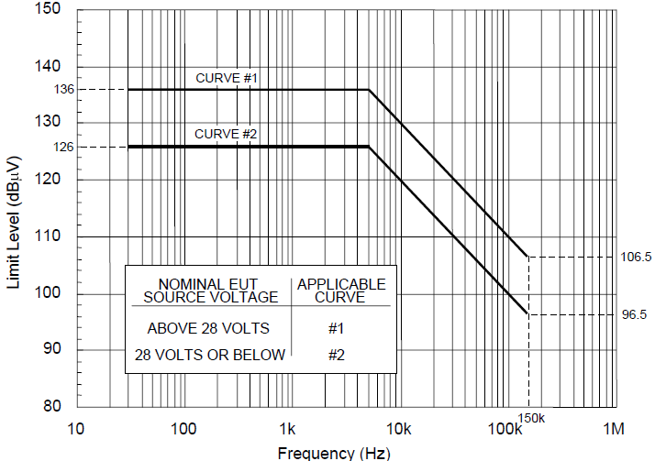
Image-13: CS101 limit line Image

CS101 Calibration
Configure the test equipment in accordance with Figure CS101-3. Set up the oscilloscope to monitor the voltage across the 0.5-ohm resistor.
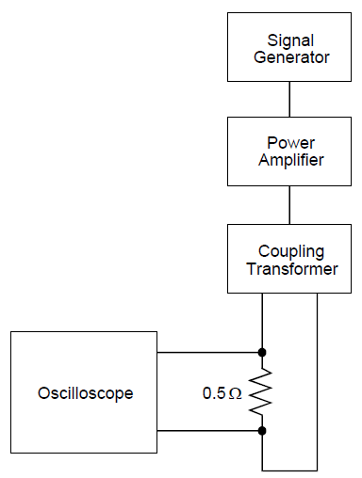
Image-14: CS101 Calibration image
CS101 Test Setup:
Maintain a basic test setup for the EUT as shown and described in Figures below
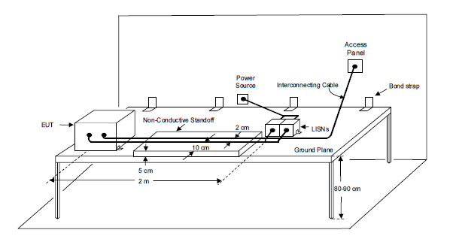
Image-15: CS101 Test Setup Image

CS101 Signal Injection, DC or Single-phase AC
For DC or single-phase AC power, configure the test equipment as shown in below Figure
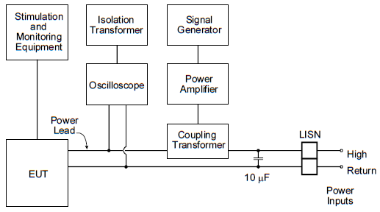
Image-16: Signal Injection, DC or Single-phase AC

CS101 Test Procedure:
Step1- Turn on the EUT and allow sufficient time for stabilization.
Step2- Set the signal generator to the lowest test frequency. Increase the signal level until the required voltage or power level is reached on the power lead.
Step3- While maintaining at least the required signal level, scan through the required
frequency range.
Step4- Susceptibility evaluation: Monitor the EUT for degradation of performance. If susceptibility is noted, determine and record its threshold level and phase position on the AC waveform and verify that it is above the limit.
Step5- Repeat (Step2) through (Step4) for each power lead and test condition, as required.

Final Measurements
The equipment shall be visually examined electrically and mechanically checked as specified and record the results in TDR-11

12.4. CS106 (Conducted Susceptibility, Power Leads, 200V,0.15μS±20%)
CS101 applicability
This requirement is applicable to submarine and surface ship equipment and subsystem AC and DC input power leads, not including grounds and neutrals.

CS106 limit.
The EUT shall not exhibit any malfunction, degradation of performance, or deviation from
specified indications, beyond the tolerances indicated in the individual equipment or subsystem specification, when subjected to a test signal with voltage levels as specified in Figure CS106-1.
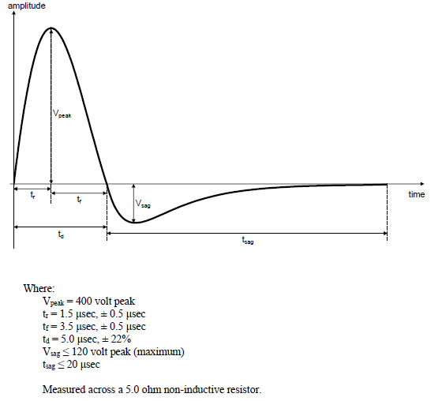
Image-17: CS106 limit line image
Test Setup:
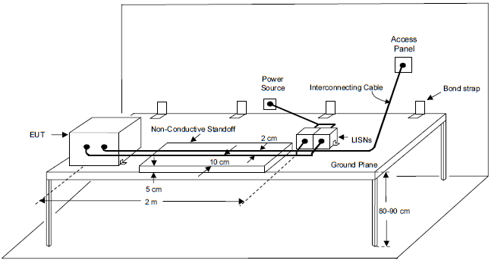
Image-18: CS106 Test Setup
Calibration:
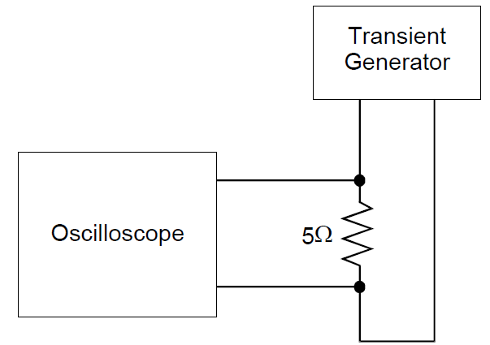
Image-19: Calibration image
Signal injection, DC or single-phase AC
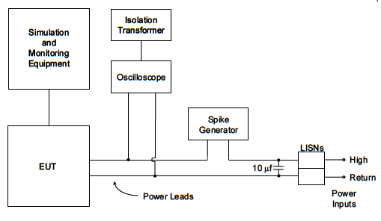
Image-20: Signal injection, DC or single-phase AC
CS106 test procedure
Step1- Turn on the EUT and allow sufficient time for stabilization.
Step2- Set the transient generator to minimum output. Increase the signal level until the required voltage is reached on the power lead or spike generator calibration set point is obtained.
Step3- While maintaining at least the required signal level, apply transient pulses to the
test sample’s ungrounded input lines at a pulse repetition rate of between 5 and 10 pulses per second for not less than 5 minutes.
Step4- Susceptibility evaluation: Monitor the EUT for degradation of performance. If susceptibility is noted, determine and record its threshold level and phase position on the AC waveform and verify that it is above the limit.
Step5- Repeat (Step2) through (Step4) for each power lead and test condition, as required.
Final Measurements
The equipment shall be visually examined electrically and mechanically checked as specified and record the results in TDR-11

12.5. CS114(Conducted Susceptibility, Bulk Cable Injection, 10 kHz to 200 MHz.)
CS114 Applicability:
This requirement is applicable to all interconnecting cables, including power cables.

CS114 Limit:
The EUT shall not exhibit any malfunction, degradation of performance, or deviation from specified indications beyond the tolerances indicated in the individual equipment or subsystem specification, when subjected to a injection probe drive level which has been pre-calibrated to the appropriate current limit and is modulated as specified below. The appropriate limit curve given in Image-21 shall be selected. Requirements are also met if the EUT is not susceptible at forward power levels sensed by the coupler that are below those determined during calibration provided that the actual current induced in the cable under test is 6 dB or greater than the calibration limit.
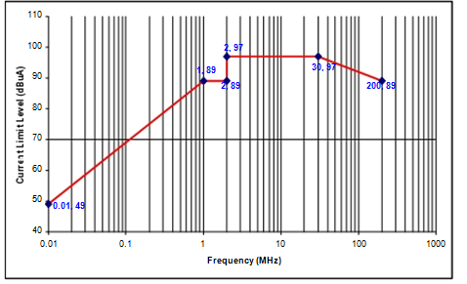

Image-21: CS114 Limit for Ground Equipment.

CS114 Test Procedure:
a) Perform Calibration as per MIL-STD-461E (CS114) Requirements.
b) Turn on the EUT and allow a sufficient time for stabilization.
c) Susceptibility evaluation:
(i) Set the signal generator to 10 kHz with 1 kHz pulse modulation, 50% duty cycle.
(ii) Apply the forward power level needed to maintain the current amplitude
required (as per CS114 Limit) determined during calibration to the injection probe while monitoring the induced current.
(iii) Scan through the required frequency range at a rate no greater than specified
in Susceptibility Test Parameters while maintaining the forward power level at
the calibration level determined, or the maximum current level for the applicable limit, whichever is less stringent.
(iv) Monitor the EUT for degradation of performance during testing.
(v) Whenever susceptibility is noted, determine the threshold level and verify that it is above the applicable requirement.
(vi) For EUTs with redundant cabling for safety critical reasons such as multiple data buses, use simultaneous multi-cable injection techniques.
d) Perform the above procedures on each cable bundle interfacing with each electrical
Connector on the EUT including complete power cables (high sides and returns). Also perform the procedures on power cables with the power returns and chassis grounds (green wires) excluded from the cable bundle. For connectors, which include both interconnecting leads and power, perform the procedures on the entire bundle, on the power leads (including returns and grounds) grouped separately, and on the power, leads grouped with the returns and grounds removed.
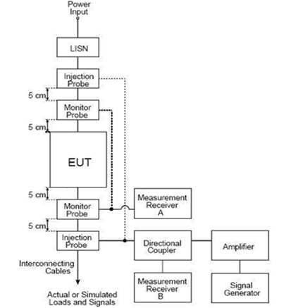

Image-22: CS114 Bulk Cable Injection Block Diagram

Final Measurements
The equipment shall be visually examined electrically and mechanically checked as specified and record the results in TDR-11

12.6. CS115 (Conducted Susceptibility, Bulk Cable Injection, Impulse Excitation).
CS115 Applicability:
This requirement is applicable to all aircraft, space and ground system interconnecting cables, including power cables. The requirement is also applicable for surface ship and submarine subsystems and equipment when specified by the procuring activity

CS115 Limit:
The EUT shall not exhibit any malfunction, degradation of performance, or deviation from specified indications beyond the tolerances indicated in the individual equipment or subsystem specification, when subjected to a pre-calibrated signal having rise and fall times, pulse width, and amplitude as specified in Figure 11 at a 30 Hz rate for one minute.

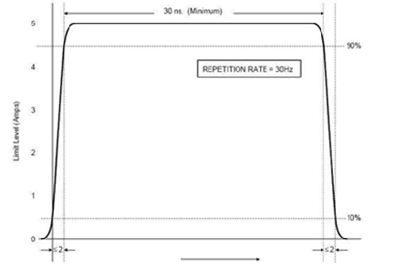
Image-23: CS115 Signal Characteristics

CS115 Test Procedure:
a) Perform Calibration as per MIL-STD-461E (CS115) Requirements.
b) Turn on the EUT and allow a sufficient time for stabilization.
c) Susceptibility evaluation:
(i) Adjust the pulse generator, as a minimum, for the amplitude setting determined during calibration.
(ii) Apply the test signal at the pulse repetition rate and for the duration specified in the requirement.
(iii) Monitor the EUT for degradation of performance during testing.
(iv) Whenever susceptibility is noted, determine the threshold level and verify that it is above the limit.
(v) Record the peak current induced in the cable as indicated on the oscilloscope.
(vi) Repeat (i) through (v) on each cable bundle interfacing with each electrical connector on the EUT. For power cables, perform (i) through (v) on complete power cables (high sides and returns) and on the power cables with the power returns and chassis grounds (green wires) excluded from the cable bundle. For connectors which include both interconnecting leads and power, perform (i) through (v) on the entire bundle, on the power leads (including returns and grounds) grouped separately, and on the power, leads grouped with the returns and grounds removed.

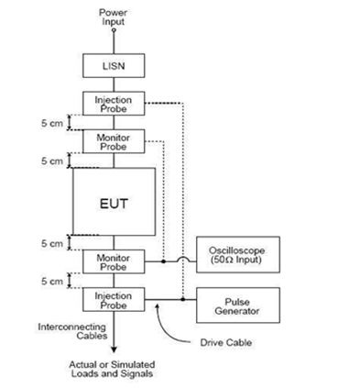

Image-24: Typical Setup for CS115 Bulk Cable Injection

Final Measurements
The equipment shall be visually examined electrically and mechanically checked as specified and record the results in TDR-11

12.7. CS116 (CS, Damped Sinusoidal Transients, Cables and Power Leads, 10 kHz to 100 MHz)

CS116 Applicability:
This requirement is applicable to all interconnecting cables, including power cables and individual high side power leads. Power returns and neutrals need not be tested individually.

CS116 Limit:
The EUT shall not exhibit any malfunction, degradation of performance, or deviation from specified indications beyond the tolerances indicated in the individual equipment or subsystem specification, when subjected to a signal having the waveform shown in Figure 13 and having a maximum current as specified in Image-25.

The limit is applicable across the entire specified frequency range. As a minimum, compliance shall be demonstrated at the following frequencies: 0.01, 0.1, 1, 10, 30, and 100 MHz. If there are other frequencies known to be critical to the equipment installation, such as platform resonances, compliance shall also be demonstrated at those frequencies. The test signal repetition rate shall be no greater than one pulse per second and no less than one pulse every two seconds. The pulses shall be applied for a period of five minutes.
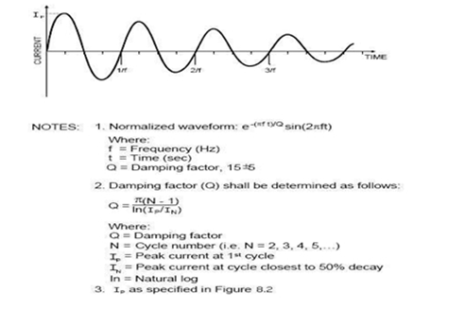

Image-25: Typical CS116 Damped Sinusoidal Waveform.

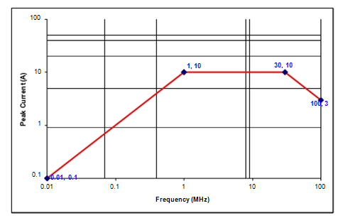

Image-26:CS116 Current Limit.

Test Setup:
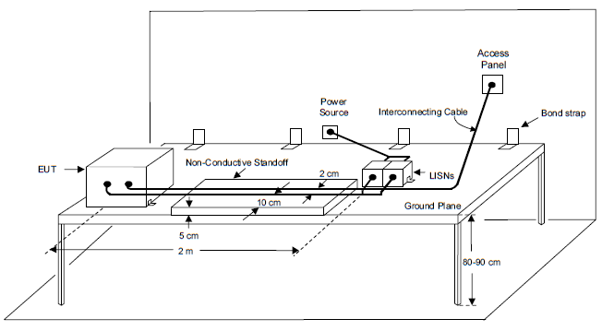
Image-27: Test Setup

CS116 Test Procedure:

a) Perform Calibration as per MIL-STD-461E (CS116) Requirements.
b) Turn on the EUT and measurement equipment to allow sufficient time for
stabilization.
c) Set the damped sine generator to a test frequency.
d) Apply the test signals to each cable or power lead of the EUT sequentially. Slowly increase the damped sine-wave generator output level to provide the specified current, but not exceeding the pre-calibrated generator output level. Record the peak current obtained.
e) Monitor the EUT for degradation of performance.
f) If susceptibility is noted, determine the threshold level and verify that it is above the specified requirements.
g) Repeat (c) through (e) for each test frequency as specified in the requirement. Repeat testing for the power-off condition.
h) Perform the above procedures, using the EUT test setup on each cable bundle
interfacing with each connector on the EUT including complete power cables. Also perform tests on each individual high side power lead (individual power returns and neutrals are not required to be tested).

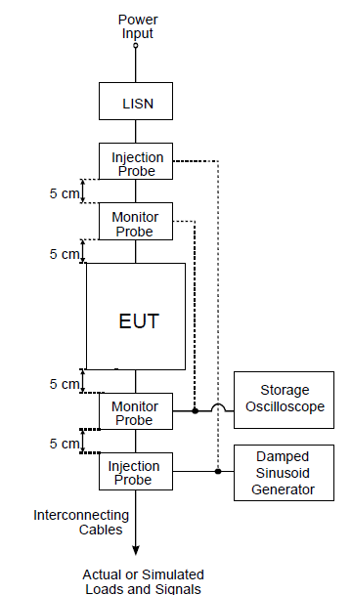

Image-28: Typical Setup for Bulk Cable Injection of Damped Sinusoidal Transients

Final Measurements
The equipment shall be visually examined electrically and mechanically checked as specified and record the results in TDR-11

12.8. RE101 (Radiated Emissions, Magnetic Field, 30 Hz to 100 kHz)
RE101 applicability
This requirement is applicable for radiated emissions from equipment and subsystem enclosures, including electrical cable interfaces. The requirement does not apply to radiation from antennas. For Navy aircraft, this requirement is applicable only for aircraft with an ASW capability.

RE101 limit
Magnetic field emissions shall not be radiated in excess of the levels shown in figure RE101-2 at a distance of 7 cm.
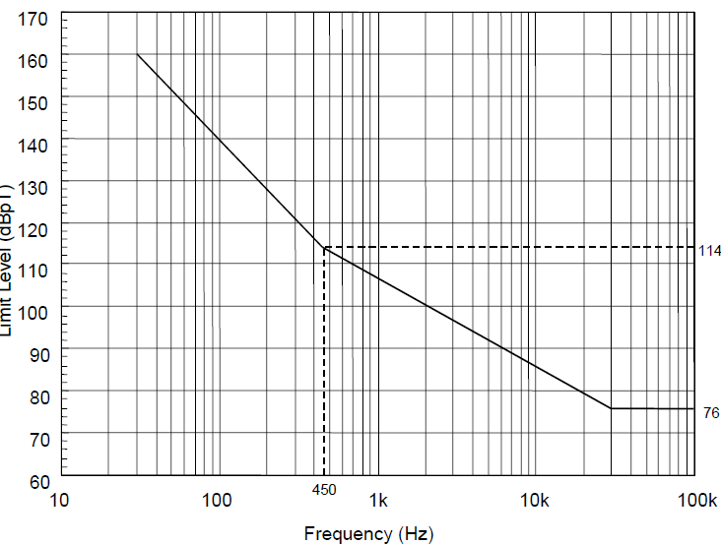
Image-29: RE101 limit for all Navy applications

Calibration Configuration
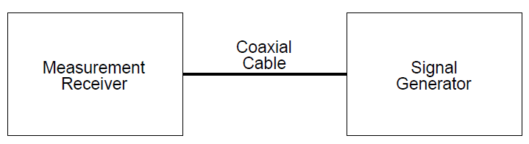
Image-30: Calibration Configuration image

Test Setup for RE101
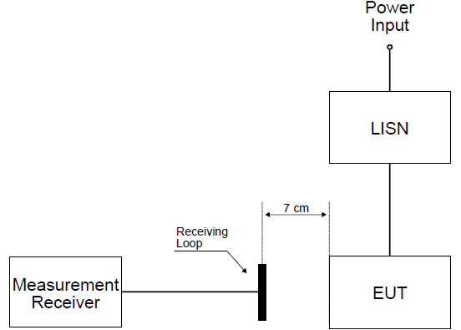
Image-31: Test Setup for RE101

Test Procedure:
Step1- Turn on the EUT and allow sufficient time for stabilization
Step2- Locate the loop sensor 7 cm from the EUT face or electrical interface connector
being probed. Orient the plane of the loop sensor parallel to the EUT faces and parallel to the axis of connectors.
Step3- Scan the measurement receiver over the applicable frequency range to locate the
frequencies of maximum radiation, using the bandwidths and minimum measurement times of Table-12.
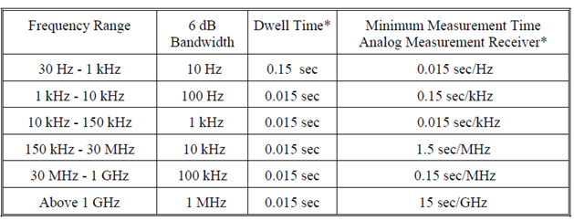
Table-12: RE101 Bandwidth and measurement time
Step4- Tune the measurement receiver to one of the frequencies or band of frequencies.
Step5- The output is monitored by the measurement receiver while moving the loop sensor over the face of the EUT or around the connector.
Step6- At 7 cm from the point of maximum radiation, the plane of the loop sensor is oriented to give a maximum reading on the measurement receiver.
Step7- These steps are repeated for at least two frequencies of maximum radiation per octave of frequencies below 200 Hz and for at least three frequencies of maximum radiation per octave above 200 Hz and for each EUT electrical connector.

Final Measurements
The equipment shall be visually examined electrically and mechanically checked as specified and record the results in TDR-11

12.9. RE102 (Radiated Emissions, Electric Field, 10kHZ up to 18 GHz)

RE102 Applicability:
This requirement is applicable for radiated emissions from equipment and subsystem enclosures, all interconnecting cables, and antennas designed to be permanently mounted to EUTs (receivers and transmitters in standby mode). The requirement does not apply at the transmitter fundamental frequencies.
As the EUT is a Navy based system, the Start frequency of this test is 10kHz.

RE102 Limit:
Electric field emissions shall not be radiated in excess of that shown in Figure 3. Above 30 MHz, the limits shall be met for both horizontally and vertically polarized fields.
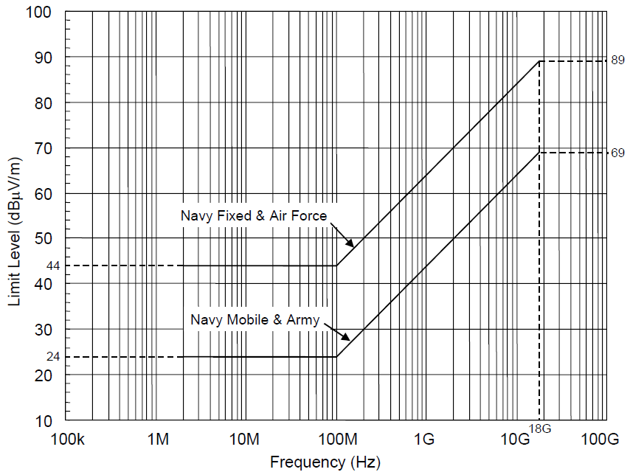
Image-32: RE102 Limit for Ground Applications

Test Setup
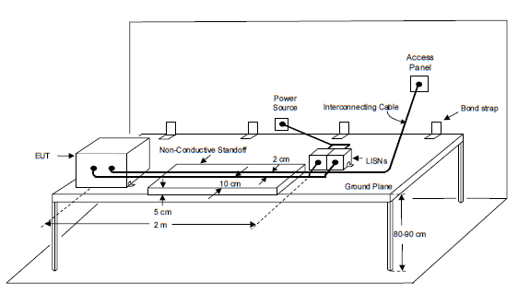
Image-33: General Test Setup

RE102 Test Procedure:
a) Perform emission data scans using the measurement setup given in Image-34 Ensure that the EUT is oriented such that the surface that produces the maximum radiated emissions is towards the front edge of the test setup boundary.
b) The Antenna Positioning should be done as indicated in Image-35. The number of required antenna positions depends on the size of the test setup boundary and the number of enclosures included in the setup. Guidelines given in MIL-STD-461E, RE102 Requirements should be followed to determine the individual antenna positions.
c) Verify that the ambient is at least 6 dB below the allowable specified limits when the tests are performed in a shielded enclosure. Take plots of the ambient when required.
d) Perform Calibration as per MIL-STD-461E (RE102) Requirements
e) Turn on the EUT and allow a sufficient time for stabilization.
f) Using the measurement path of Image-34, determine the radiated emissions from the EUT and its associated cabling.
g) Scan the measurement receiver for each applicable frequency range, using the bandwidths and minimum measurement times in Emission Test Parameters.
h) Above 30 MHz, orient the antennas for both horizontally and vertically polarized fields.
i) Take measurements for each antenna position determined above.
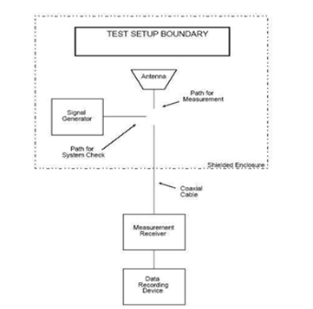
Image-34: RE102 Basic Test Setup

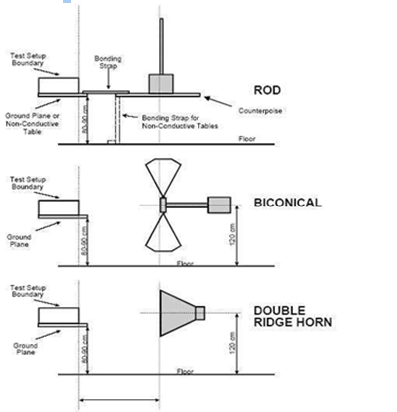

Image-35: Antenna Positioning

Image-35: Antenna Position
Final Measurements
The equipment shall be visually examined electrically and mechanically checked as specified and record the results in TDR-11

12.10. RS101 (Radiated Susceptibility, Magnetic Field, 30 Hz to 100 kHz)
RS101 applicability.
This requirement is applicable to equipment and subsystem enclosures, including electrical cable interfaces. The requirement is not applicable for electromagnetic coupling via antennas. For equipment intended to be installed on Navy aircraft, the requirement is applicable only to aircraft with ASW capability. For Army ground equipment, the requirement is applicable only to vehicles having a minesweeping or mine detection capability. For submarines, this requirement is applicable only to equipment and subsystems that have an operating frequency of 100 kHz or less and an operating sensitivity of 1 μV or better (such as 0.5 μV).

RS101 limit
EUT shall not exhibit any malfunction, degradation of performance, or deviation from
specified indications, beyond the tolerances indicated in the individual equipment or subsystem specification, when subjected to the magnetic fields shown in Figures below
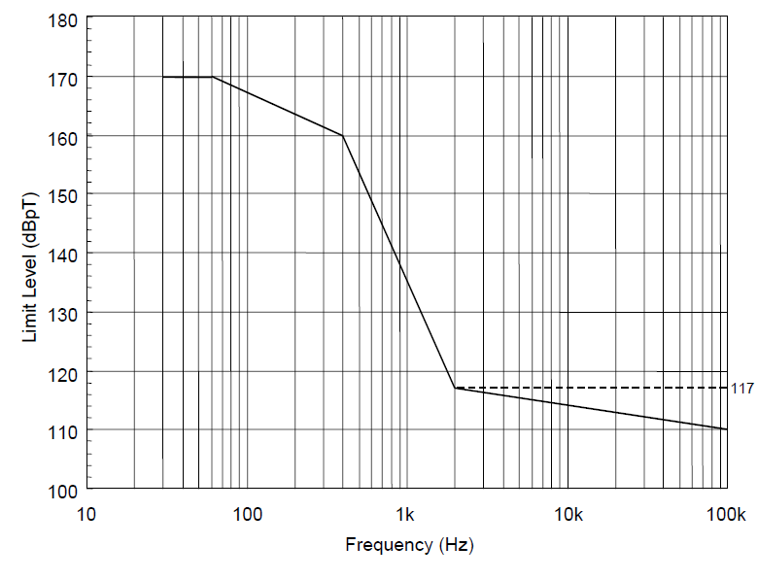
Image-36: RS101 limit for all Navy applications

Test Setup

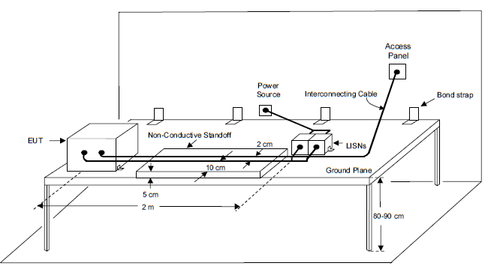

Image-37: Test Setup Image

Configuration test Setup
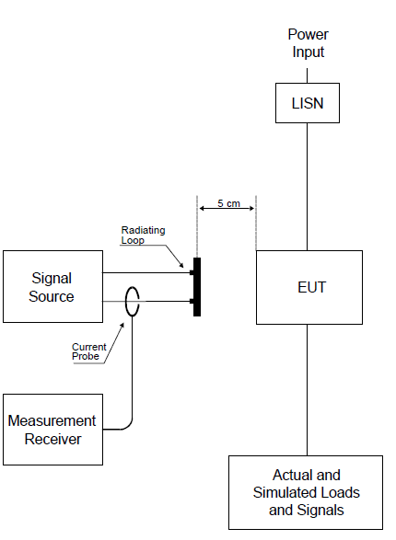
Image-38: Configuration Test Setup image

Calibration:
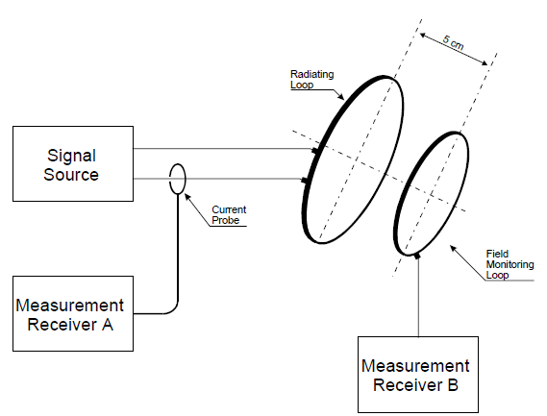
Image-39: Calibration of the radiating system

Test Procedure:
Step1- Turn on the EUT and allow sufficient time for stabilization
Step2- Select test frequencies as follows
a) Locate the loop sensor 5 cm from the EUT face or electrical interface connector being probed. Orient the plane of the loop sensor parallel to the EUT faces and parallel to the axis of connectors.
(b) Supply the loop with sufficient current to produce magnetic field strengths at least 10 dB greater than the applicable limit but not to exceed 15 amps (183 dBpT).
(c) Scan the applicable frequency range using the scan rates in below Table-13.
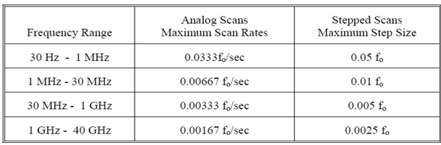
Table-13: RS101 Susceptibility Scanning
(d) If susceptibility is noted, select no less than three test frequencies per octave at those frequencies where the maximum indications of susceptibility are present.
(e) Reposition the loop successively to a location in each 30 by 30 cm area on each face of the EUT and at each electrical interface connector, and repeat (Step2) (c) and (Step2) (d) to determine locations and frequencies of susceptibility.
(e) Reposition the loop successively to a location in each 30 by 30 cm area on each face of the EUT and at each electrical interface connector, and repeat (Step2) (c) and (Step2) (d) to determine locations and frequencies of susceptibility.
(f) From the total frequency data where susceptibility was noted in (Step2) (c) through (Step2) (e), select three frequencies per octave over the applicable frequency range.
Step3- At each frequency determined in (Step2) (f), apply a current to the radiating loop that corresponds to the applicable limit. Move the loop to search for possible locations of susceptibility with particular attention given to the locations
determined in (Step2) (e) while maintaining the loop 5 cm from the EUT surface or connector. Verify that susceptibility is not present.
Final Measurements
The equipment shall be visually examined electrically and mechanically checked as specified and record the results in TDR-11

12.11. RS103 (Radiated Susceptibility, Electric Field, 2 MHz to 40 GHz).

RS103 Applicability:
This requirement is applicable to equipment and subsystem enclosures and all interconnecting cables. The requirement at the tuned frequency of an antenna-connected receiver is 20 dB above the RE102 limit associated with the particular platform application.
RS103 Limit:
The EUT shall not exhibit any malfunction, degradation of performance, or deviation from specified indications, beyond the tolerances indicated in the individual equipment or subsystem specification, when subjected to the radiated electric fields of 50 V/m throughout the frequency range of 2 MHz to 40 GHz and modulated as specified below. Up to 30 MHz, the requirement shall be met for vertically polarized fields. Above 30 MHz, the requirement shall be met for both horizontally and vertically polarized fields. Circular polarized fields are not acceptable.

RS103 Test Procedure:
a) Maintain a basic setup as given in Figure 16. Electric field sensors are required from 2 MHz to 1 GHz. Either field sensors or receive antennas may be used above 1 GHz.
b) The number of required antenna and sensor positions depends on the size of the test setup boundary and the frequency of radiation. Guidelines given in MIL-STD-461E, RS103 Requirements should be followed to determine the individual antenna and sensor positions.
c) Assess the test area for potential RF hazards and take necessary precautionary steps to assure safety of test personnel.
d) Perform Calibration as per MIL-STD-461E (RS103) Requirements
e) Turn on the EUT and allow a sufficient time for stabilization.
F) E-Field Sensor Procedure: As shown in Figure 16
(i) Set the signal source to 1 kHz pulse modulation, 50% duty cycle, and using
appropriate amplifier and transmit antenna, establish an electric field at the test start frequency. Gradually increase the electric field level until it reaches the applicable limit.
(ii) Scan the required frequency ranges in accordance with the rates and durations
specified in Susceptibility Test Parameters. Maintain field strength levels in
accordance with the applicable limit. Monitor EUT performance for susceptibility
effects.
g) Receive Antenna Procedure:
(i) Remove the receive antenna and reposition the EUT in conformance with Figure 17.
(ii) Set the signal source to 1 kHz pulse modulation, 50% duty cycle. Using an appropriate amplifier and transmit antenna, establish an electric field at the test start frequency. Gradually increase the input power level until it corresponds to the applicable level recorded during the calibration routine.
(iii) Scan the required frequency range in accordance with the rates and durations specified in Susceptibility Test Parameters while assuring the correct transmitter input power is adjusted in accordance with the calibration data collected. Constantly monitor the EUT for susceptibility conditions.
h) If susceptibility is noted, determine the threshold level and verify that it is above the limit.
i) Perform testing over the required frequency range with the transmit antenna vertically polarized. Repeat the testing above 30 MHz with the transmit antenna horizontally polarized.
j) Repeat the test procedures for each transmit antenna position required.
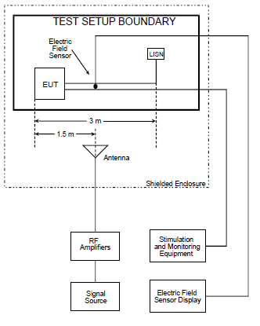

Image-40: RS103 Basic Test Equipment Configuration (Using Sensor)

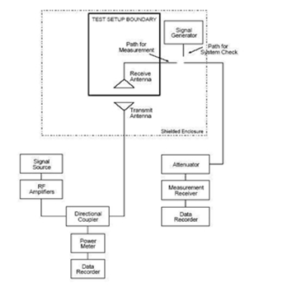

Image-41: RS103 Basic Test Equipment Configuration (Using Receive Antenna)

Recovery - The equipment shall then be removed from the chamber and shall be restored to laboratory atmospheric conditions within 30 minutes for a period of 2 to 4 hours.
Final Measurements - The equipment shall then be visually examined and shall be electrically and mechanically checked as specified and record the results.
Final Measurements
The equipment shall be visually examined electrically and mechanically checked as specified and record the results in TDR-11

12.0 Defect / Failure Analysis: Defect/failure investigation is to be done, entered in the format mentioned in Appendix-A for any failure during any of the tests and filed with the results.

TEST DATA RECORD-1

Test Name: PHYSICAL INSPECTION Date:
Project No.: DP239057 Unit Part No.: DBPL-15HDT-01
PO. No.: BEPO/GD3/4000392872 BEL Part No.: 4461 415 601 19
Description: 15.6” MTID-RUGGED Sl.no.

1. PHYSICAL INSPECTION:
S.No | Test | Requirement | Result
1 | KVM damages check | No damages | OK /NOT OK
2 | Power circular mating and insertion at the power socket. | Proper fitment | OK /NOT OK
3 | All the connectors power & signal | No loose pins / wires | OK /NOT OK

2. DIMENSIONAL CHECK:
S. No | Description | Specified Dimensions(mm) | Measured  Dimensions(mm) | Result
1 | Width | 436 |  | OK /NOT OK
2 | Height | 281 |  | OK /NOT OK
3 | Depth | 74.5 |  | OK /NOT OK
4 | Weight | <7 Kgs |  | OK /NOT OK

FINAL RESULT : CLEARED ------ / NOT CLEARED……

Remarks If any: ……………………………………………………………………...……………………

DATASOL-REP.: ............................................…… BEL-REP: ...................…............................….

TEST DATA RECORD-2

Test Name: VIBRATION Date:
Project No.: DP239057 Unit Part No.: DBPL-15HDT-01
PO. No.: BEPO/GD3/4000392872 BEL Part No.: 4461 415 601 19
Description: 15.6” MTID-RUGGED Sl.no.
Test condition: Before mounting the display on vibration chamber, check the functionality of display and also check functionality after each axis.

FUNCTIONAL TEST:
S.No | TEST | REQUIREMENT | X-AXIS | Y-AXIS | Z-AXIS
1 | Fuctionality of Display:  System booting display seen on the screen of MTID-Rugged. | Observe:  Resolution up to 1920 X 1080 | OK / NOT OK | OK / NOT OK | OK / NOT OK

FINAL RESULT : CLEARED ------ / NOT CLEARED ……

Remarks If any: ……………………………………………………………………...……………………

DATASOL-REP.: ............................................…… BEL-REP: ...................…............................….

TEST DATA RECORD-3

Test Name: HIGH TEMPERATURE Date:
Project No.: DP239057 Unit Part No.: DBPL-15HDT-01
PO. No.: BEPO/GD3/4000392872 BEL Part No.: 4461 415 601 19
Description: 15.6” MTID-RUGGED Sl.no.:
Test Started on: ………..………….. Test Completed on: …….…………………….
Test condition: Before placing the unit in chamber performe the functional test and also check the functional test at last one hour and power off the unit.

FUNCTIONAL TEST:
S.No | TEST | REQUIREMENT | RESULT
1 | Fuctionality of Display:  System booting display seen on the screen of MTID-Rugged. | Observe:  Check the Resolution up to 1920 X 1080 | OK / NOT OK

FINAL RESULT : CLEARED ------ / NOT CLEARED……

Remarks If any: ……………………………………………………………………...……………………

DATASOL-REP.: ............................................…… BEL-REP: ...................…............................….

TEST DATA RECORD-4

Test Name: DAMP HEAT Date:
Project No.: DP239057 Unit Part No.: DBPL-15HDT-01
PO. No.: BEPO/GD3/4000392872 BEL Part No.: 4461 415 601 19
Description: 15.6” MTID-RUGGED Sl.no.:
Test Started on: ………..………….. Test Completed on: …….…………………….
Test condition: Before placing the unit in chamber performe the functional test and also check the functional test at last 30 minutes and power off the unit.

FUNCTIONAL TEST:
S.No | TEST | REQUIREMENT | RESULT
1 | Fuctionality of Display:  System booting display seen on the screen of MTID-Rugged. | Observe:  Check the Resolution up to 1920 X 1080 | OK / NOT OK

FINAL RESULT : CLEARED ------ / NOT CLEARED……

Remarks If any: ……………………………………………………………………...……………………

DATASOL-REP.: ............................................…… BEL-REP: ...................…............................….

TEST DATA RECORD-5

Test Name: LOW TEMPERATURE Date:
Project No.: DP239057 Unit Part No.: DBPL-15HDT-01
PO. No.: BEPO/GD3/4000392872 BEL Part No.: 4461 415 601 19
Description: 15.6” MTID-RUGGED Sl.no.:
Test Started on: ………..………….. Test Completed on: …….…………………….
Test condition: Before placing the unit in the chamber performe the functional test and also check the functional test at last 30 Minutes and power off the unit.

FUNCTIONAL TEST:
S.No | TEST | REQUIREMENT | RESULT
1 | Fuctionality of Display:  System booting display seen on the screen of MTID-Rugged. | Observe:  Check the Resolution up to 1920 X 1080 | OK / NOT OK

FINAL RESULT : CLEARED ------ / NOT CLEARED……

Remarks If any: ……………………………………………………………………...……………………

DATASOL-REP.: ............................................…… BEL-REP: ...................…............................….

TEST DATA RECORD-6

Test Name: DRIP PROOF Date:
Project No.: DP239057 Unit Part No.: DBPL-15HDT-01
PO. No.: BEPO/GD3/4000392872 BEL Part No.: 4461 415 601 19
Description: 15.6” MTID-RUGGED Sl.no.:
Test Started on: ………..………….. Test Completed on: …….…………………….
Test condition:
During the test performe the functional test.

FUNCTIONAL TEST:
S.No | TEST | REQUIREMENT | RESULT
1 | Fuctionality of Display:  System booting display seen on the screen of MTID-Rugged. | Observe:  Check the Resolution up to 1920 X 1080 | OK / NOT OK

FINAL RESULT : CLEARED ------ / NOT CLEARED……

Remarks If any: ……………………………………………………………………...……………………

DATASOL-REP.: ............................................…… BEL-REP: ...................…............................….

TEST DATA RECORD-7

Test Name: TROPICAL EXPOSURE Date:
Project No.: DP239057 Unit Part No.: DBPL-15HDT-01
PO. No.: BEPO/GD3/4000392872 BEL Part No.: 4461 415 601 19
Description: 15.6” MTID-RUGGED Sl.no.:
Test Started on: ………..………….. Test Completed on: …….…………………….
Test condition: Before starting the test performe the functional test and also check the functional test after test.

FUNCTIONAL TEST:
S.No | TEST | REQUIREMENT | RESULT
1 | Fuctionality of Display:  System booting display seen on the screen of MTID-Rugged. | Observe:  Check the Resolution up to 1920 X 1080 | OK / NOT OK

FINAL RESULT : CLEARED ------ / NOT CLEARED……

Remarks If any: ……………………………………………………………………...……………………

DATASOL-REP.: ............................................…… BEL-REP: ...................…............................….

TEST DATA RECORD-8

Test Name: MOULD GROWTH Date:
Project No.: DP239057 Unit Part No.: DBPL-15HDT-01
PO. No.: BEPO/GD3/4000392872 BEL Part No.: 4461 415 601 19
Description: 15.6” MTID-RUGGED Sl.no.:
Test Started on: ………..………….. Test Completed on: …….…………………….
Test condition: To be conducted on representative samples.

FUNCTIONAL TEST:
S.No | TEST | REQUIREMENT | RESULT
1 | Fuctionality of Display:  System booting display seen on the screen of MTID-Rugged. | Observe:  Check the Resolution up to 1920 X 1080 | OK / NOT OK

FINAL RESULT : CLEARED ------ / NOT CLEARED……

Remarks If any: ……………………………………………………………………...……………………

DATASOL-REP.: ............................................…… BEL-REP: ...................…............................….

TEST DATA RECORD-9

Test Name: CORROSION SALT Date:
Project No.: DP239057 Unit Part No.: DBPL-15HDT-01
PO. No.: BEPO/GD3/4000392872 BEL Part No.: 4461 415 601 19
Description: 15.6” MTID-RUGGED Sl.no.:
Test Started on: ………..………….. Test Completed on: …….…………………….
Test condition: To be conducted on representative samples.

FUNCTIONAL TEST:
S.No | TEST | REQUIREMENT | RESULT
1 | Fuctionality of Display:  System booting display seen on the screen of MTID-Rugged. | Observe:  Check the Resolution up to 1920 X 1080 | OK / NOT OK

FINAL RESULT : CLEARED ------ / NOT CLEARED……

Remarks If any: ……………………………………………………………………...……………………

DATASOL-REP.: ............................................…… BEL-REP: ...................…............................….

TEST DATA RECORD-10

Test Name: SHOCK TEST Date:
Project No.: DP239057 Unit Part No.: DBPL-15HDT-01
PO. No.: BEPO/GD3/4000392872 BEL Part No.: 4461 415 601 19
Description: 15.6” MTID-RUGGED Sl.no.:
Test Started on: ………..………….. Test Completed on: …….…………………….
Test condition: To be conducted on representative samples.
After test completed check visual and functional.

FUNCTIONAL TEST:
S.No | TEST | REQUIREMENT | RESULT
1 | Fuctionality of Display:  System booting display seen on the screen of MTID-Rugged. | Observe:  Check the Resolution up to 1920 X 1080 | OK / NOT OK

FINAL RESULT : CLEARED ------ / NOT CLEARED……

Remarks If any: ……………………………………………………………………...……………………

DATASOL-REP.: ............................................…… BEL-REP: ...................…............................….

TEST DATA RECORD-11

Test Name: Date:
Project No.: DP239057 Unit Part No.: DBPL-15HDT-01
PO. No.: BEPO/GD3/4000392872 BEL Part No.: 4461 415 601 19
Description: 15.6” MTID-RUGGED Sl.no.:
Test Started on: ………..………….. Test Completed on: …….…………………….
Test condition:

FUNCTIONAL TEST:
S.No | TEST | REQUIREMENT | RESULT
1 | Fuctionality of Display:  System booting display seen on the screen of MTID-Rugged. | Observe:  Check the Resolution up to 1920 X 1080 | OK / NOT OK

FINAL RESULT : CLEARED ------ / NOT CLEARED……

Remarks If any: ……………………………………………………………………...……………………

DATASOL-REP.: ............................................…… BEL-REP: ...................…............................….

Appendix A

DIR  Defect  Investigation  Report | Unit Description:  Unit Sl. No.:
DI NO. | TYPE OF MODIFICATION
DATE: | H/W | S/W N/A |  | BOTH N/A
S/W VERSION: N/A |  |  | CHECK SUM:
PROBLEM REPORTED DURING:

PROBLEM DESCRIPTION:

MODULE / COMPONENT AFFECTED:

DEFECT ANALYSIS & CAUSE OF PROBLEM:

REPAIR / REMEDIAL ACTION:

FOLLOW UP ACTION:

OEM. Rep BEL Design Rep

THIS IS LAST PAGE

